|  |  |
| --- | --- |
| English  Texts:  Our main text this term will be The Viewer by Gary Crew and Shaun Tan | Maths  Multiplication / division.  Fractions, decimals, percentages. |
| RE  What would Jesus do?  Geography  Save our Planet (climates, biomes, climate change, global warming)  Science  Living things and their habitats (Classification)  P.S.H.E.  Keeping myself safe  French  My house / my pets | PE  Gymnastics  Dance |
| Art  Environmental and recycled art / Andy Goldsworthy  DT  Primary Engineers Award  Music  Rhythm and percussion (Stomp) |
| Computing  Programming: variables in games |

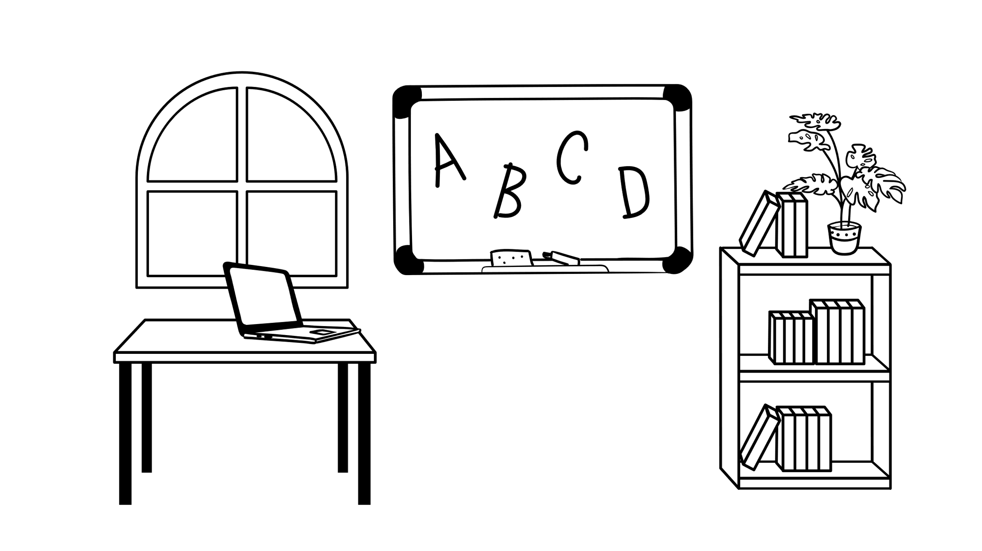Herne View Church of England Primary School Year Five Newsletter – Spring 2024

|  |
| --- |
| Here is an overview of the learning we will be doing in Year 5 over Spring as well as some information about our classroom organisation.  **How you can help your child:**  •Practise times tables up to 12x until your child is fluent. TTRockstars is a homework activity and your child will be asked to use it for a minimum of 30 minutes each week.  •Daily reading is also a required homework activity. We ask that all children read 5 times a week for at least 10 minutes on each occasion. This should then be recorded in your child’s reading diary.  •There may also be additional learning activities set. These might be research tasks or fact-finding missions.  • Please discuss the key concepts on your child’s Knowledge Organisers with them.  **Reading Records**: Please send your child in with their reading record and reading book every day. Ensure the reading record is signed weekly to show that the homework of reading 5 times a week has been completed. These are checked at school and awards are given to children who successfully complete this.  **PE kit**: Our PE days are Mondays (Bartletts) / Tuesdays (Russet) and Fridays (both) this term. Children can wear their PE kit on these days. Please note that children are not permitted to wear earrings on PE days and long hair should be tied up.  **Uniform**: Please label uniform clearly (especially jumpers and cardigans) and please note that any children wearing nail varnish will be required to remove it immediately.  Any issues or problems do not hesitate to contact your child’s class teacher via Class Dojo or through the school office. |